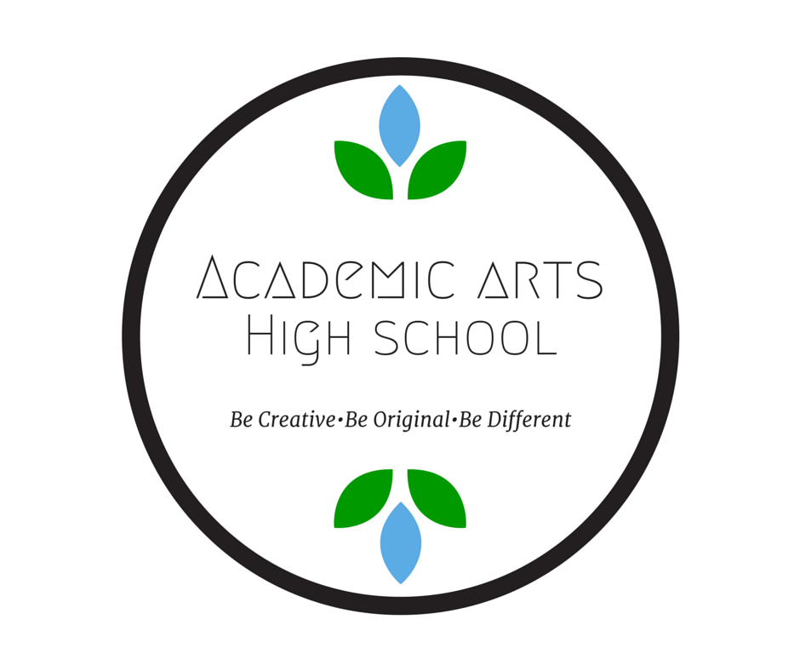

Academic Arts High School

  - PUBLIC CHARTER SCHOOL DISTRICT # 4119-07

SCHOOL YEAR 2016-2017

WORLD’S BEST WORKFORCE & ANNUAL REPORT
Table of Contents
School Information 3
Implementation of Primary and Additional Statutory Purposes 4
Student Enrollment & Demographics 4
Student Attendance, Attrition & Mobility 5
Educational Approach & Curriculum 6
Innovative Practices & Implementation 11
Key successes from the past school year 11
Key challenges from past school year 12
Academic Performance: Goals & Benchmarks 13
Educational Effectiveness: Assessment & Evaluation 21
Student & Parent Satisfaction 22
Environmental Education 23
Governance & Management 24
Board Training and Development 25
MANAGEMENT 26
Staffing 28
Operational Performance 31
Finances 32
Future Plans 33
Appendix 1: NWEA Growth Index Points Calculations 34

School Information

Contact Information
Kelley Thompson, Lead Language Arts Teacher
60 East Marie Avenue, Suite 220
651-457-7427
www.academicarts.org
Grades Served: 9-12
Year Opened: 2004
This report was completed in collaboration with Andrea Krause, Client Services Coordinator, Designs for Learning. 651/255-8855 or akrause@designlearn.net

Mission and Vision
Mission: Learn by doing. Embrace your place in the world, prepare for the future. And make friends along the way.
Vision: At AAHS, our vision is a generation of young people who can navigate the world with the awareness, knowledge, attitudes, and skills necessary to make a positive impact. In an increasingly complex time, it can be difficult to know the right path. At AAHS, we focus on our strong community where we get to know each other as individuals, encourage each other when times get tough, hold each other accountable, and work together to succeed.

Authorizer Information
Academic Arts High School's authorizer is the Audubon Center of the North Woods (ACNW). Academic Arts High School is able to, with the ongoing support of ACNW through superior oversight, evaluation, feedback, and strategic support, keep the school a safe place for students that adheres to the academic, financial, operational, and environmental education performance goals agreed upon in their authorizer contract. The authorizing vision of ACNW is to authorize a portfolio of high performing charter schools that instill a connection and commitment to the environment in their school communities while working towards a healthy planet where all people live in balance with the Earth. Academic Arts High School strives to be a model school that fits this vision.
The authorizing mission of ACNW is to ensure quality academic and environmental literacy outcomes for students in Minnesota by conducting effective oversight and evaluation of its authorized schools, providing strategic support to schools, and making informed and merit-based decisions about its portfolio of charter schools.

David Greenberg, Director of Charter School Authorizing
Audubon Center of the North Woods
Charter School Division
43 Main St. S.E., Suite #507
Minneapolis, MN 55414
612-331-4181
www.auduboncharterschools.org

Implementation of Primary and Additional Statutory Purposes
Academic Arts High School meets the primary statutory purpose of charter schools: to improve pupil learning and student achievement, by striving to create a learning community where students become active, caring citizens and inquisitive, resourceful lifelong learners. Efforts to implement this type of learning community in our school will be described throughout this report.
AAHS also seeks to meet the additional statutory purposes of a charter school: the program increases learning opportunities by providing a small, project-based program where students who may not thrive in traditional high schools can learn and build their unique paths toward graduation and beyond. We incorporate innovative teaching through our project-based learning platform focusing on artistic expression. We are continuously developing measurement outcomes and accountability methods to gauge students’ progress. As a small, close-knit school, teachers can give input and guide the development of the school. We are working to cultivate a more balanced school board with three teacher members, one parent member, and three community members.
Regarding the components of the World’s Best Workforce, AAHS focuses on ensuring all students are ready for life after high school through career skills development and college readiness.

Student Enrollment & Demographics

STUDENT ENROLLMENT
Enrollment at Academic Arts High School has steadily increased at a sustainable rate over the last several years. This year we reached our targeted enrollment of 140. The challenge now is to increase student attendance so that our ADM reflects current enrollment.
Number of Students Enrolled | 2015-16 | 2016-17 | 2017-18 (est.)
9th Grade | 18 | 21 | 21
10th Grade | 50 | 27 | 27
11th Grade | 42 | 40 | 40
12th Grade | 21 | 53 | 53
Total | 131 | 141 | 141
Total ADM (Average Daily Membership) for year | 95.41 | 96.64 | 96.64

STUDENT DEMOGRAPHICS
Demographics at Academic Arts have remained similar from year to year. Our school consistently sits at around 30% Special Education students and 45% Free and Reduced Lunch. We also see a very small percentage of Homeless and English Learner students from year to year. Our student body continues to be ethnically diverse, in alignment with our mission of developing world-learners.
Demographic Trends | 2015-16 | 2016-17 | 2017-18 (est.)
Total Enrollment | 94 | 141 | 141
Male | 45 | 70 | 70
Female | 49 | 71 | 71
Special Education | 23 | 46 | 46
English Learners | 5 | 4 | 4
Free/Reduced Priced Lunch | 47 | 72 | 72
Black, not of Hispanic Origin | 7 | 22 | 22
Hispanic/Latino | 19 | 33 | 33
Asian/Pacific Islander | 3 | 2 | 2
American Indian/Alaskan Native | 0 | 12 | 12
White, not of Hispanic Origin | 64 | 72 | 72

Student Attendance, Attrition & Mobility

STUDENT ATTENDANCE
Regular attendance from our students continues to be a challenge at Academic Arts High School (AAHS). This school year was no different, and while we saw an increase from last year to this year, our attendance rate is still below our goal. AAHS has averaged 81% attendance over the last three years.
This year, AAHS implemented a new program called REACH, which will be discussed further in in later sections. The program facilitates relationship building and goal setting with students, both of which improve attendance. The hope is that continued use of this program will result in more consistent attendance in the next school year.
 | 2014-15 | 2015-16 | 2016-17
Overall Student Attendance Rate | 85% | 77.5% | 81.58%

STUDENT ATTRITION
We are pleased to see an increase in our student retention over the last year. During FY16, our October 1 to October 1 retention was at 44.72%, this year we saw 62.59% retention, a 21.87% increase from one school year to the next.
The percentage of students who were enrolled in the spring, and returned the next year in the fall has also increased. During FY16 our continued enrollment percentage was 50.88%, in FY17 this increased to 89.36%; which is an increase of 38.48% from one school year to the next. This is a great success and contributed to our higher enrollment numbers for this school year.
Percentage of students* who were continuously enrolled between October 1 of the 2015-2016 school year and October 1 of the 2016-17 school year. | 62.59%
*Do not include graduating students or those who have completed your school program, i.e., if your school is K-6, do not include students who have completed 6th grade.
Percentage of students* who continued enrollment in the school from Spring 2016 to October 1, 2016. | 89.36%
*Do not include graduating students or those who have completed your school program, i.e., if your school is K-6, do not include students who have completed 6th grade.

STUDENT MOBILITY
 | Summer Transfers In | Number of students on Oct. 1 | Mid-year Transfers In | Mid-year Transfers Out | Total Mid-year Transfers | Mobility Index* (as a percent)
2013-14 | 4 | 87 | 42 | 9 | 33 | 37%
2014-15 | 1 | 79 | 45 | 19 | 26 | 32%
2015-16 | 5 | 94 | 42 | 23 | 19 | 20%
* Total mid-year transfers divided by number of students on October 1.
Continuing our positive enrollment and retention trends, we are pleased to report a continued decrease in student mobility at AAHS. Mobility references the number of students transferring in or out of the school during the school year. This year we continued to see a high number of students transferring into the school district, and a lower number transferring out.
Percentage of students who were enrolled for 95% or more of the 2016-17 school year. | 40.42%

Academic Arts High School has worked over the last three years to increase our overall attendance percentage, student retention, and increase student enrollment. We see the 2016/17 school year as our best year for all three of these attendance goals. After the 2012/13 school year, where we lost many students due to lagging construction projects, we worked steadily to repair the damage to the school’s reputation and our enrollment numbers. During 2016/17 we saw steady attendance, steady retention and an overall increase in enrollment.

Educational Approach & Curriculum
The Academic Arts High School educational approach is to: “Learn by doing, embrace your place in the world, prepare for success, and make friends along the way.” AAHS utilizes a foundational approach to student success. AAHS values information, techniques, and skills that are learned outside of the classroom and seeks to integrate core classes with Project Based Learning and traditional lecture-based classes. Project Based Learning (PBL) enables students to complete practical work that reflects their interests, in school and out of school skills, work independently, and collaborate with other students. This school model ensures students receive an education which aligns with state standards and caters to their interests. In the “real” world, where technology and knowledge are changing on a daily basis, it is imperative that students learn how to learn. It is necessary that students understand how to comprehend the information they are receiving and work with it. Project-based learning allows students to cultivate this skill. Traditional classroom time develops the core foundational skills needed for advanced and lifelong learning, and PBL gives students the time to apply those skills in a way relevant to their interests and passions.
The AAHS program uses a combination of traditional teaching for core subjects and Project Based Learning, that is teacher guided and student driven, for electives. Students work independently to develop strong self-advocacy skills. A student-driven project is a project designed by a student with the guidance of their advisor. The advisor ensures that the project addresses state standards for learning. Teacher-driven projects are devised by a student’s advisor; they are based on MN state standards and align with students' credit needs. Group work is highlighted during projects, encouraging students to learn effective communication and collaboration. Self-advocacy and teamwork skills are essential for students to thrive in post-secondary education and careers.
Experiential Learning is a cornerstone of AAHS’ educational approach. Experiential learning theory defines learning as “the process whereby knowledge is created through the transformation of experience. Knowledge results from the combination of grasping and transforming experience”. There are two ways in which people learn, some students learn through experiencing the concrete or tangible learning experiences. Others learn best through thought and analysis. (Kolb, et al). Teachers at Academic Arts use Experiential Learning to engage both types of learning. Also, field trips and excursions are utilized for concrete learning experiences, and presentations for analysis and reflection on these experiences.
Below is a summary of highlights from AAHS Experiential Learning excursions during the 2016-2017 school year.
- Environmental Education Excursions. There were six overnight camping excursions during this school year. To prepare for camping trips, students plan meals, gear, and their route. Planning involves calculating appropriate nutrition and food amounts, so we do not waste resources or lack them. They must also select their gear, so we have the correct number of tents, sleeping bags, etc. so everyone has a place to sleep. Then they select our hiking route and campsite according to the Leave No Trace Principles which are incorporated into our school culture.
  - Two overnight trips at the Audubon Center of the Northwoods, December 7-9, 2016 and April 11-13, 2017.
  - Will Steger Center, May 12^{th,} 2017. Students volunteered with Will Steger who is a Polar Explorer and wilderness conservationist. In 2013 he began the process of developing a non-profit and Wilderness Center. In May of 2016 students spent several days at the Wilderness Center working with Will on his current projects to set up the center.
  - Hiking Trips: During the School year we took three multi-day camping trips: Fall Camping Trip #1: September 22-23, Fall Camping Trip #2: October 19-20, Will Steger Camping Trip: Thursday, May 11 - Saturday, May 13.
- Students toured CHS Baseball Field in Saint Paul, MN. CHS field is a green certified building. Students toured the facility with the architects and engineers who illustrated how the building was designed and built as an Eco-Friendly structure. This trip was part of our City Planning Environmental Education unit.
- Union Depot Field Trip: Students toured Union Depot with Depot employees who explained the history of the building and how it has been renovated and adapted as usage changed over the years. Students could learn about the most recent renovation and how it was done in alignment with Eco-Friendly principles.
- Bike Incentive Program: a group of students worked on a Bike Incentive Program. They collected donated bicycles from the community, learned how to fix them, built a bike rack for the school out of salvaged materials, and planned safe routes to commute to and from school. Academic Arts now has a fleet of bicycles and helmets for students to check out and use.
- Intermedia Arts and Academic Arts formed a partnership over the school year. During our social & environmental justice unit students attended a gallery show at Intermedia Arts. After meeting with the staff and participants in the show, AAHS were invited to attend their Open Mic Night. Intermedia arts provided the transportation for students to both of these events.
- The City of Minneapolis is developing park space by Saint Anthony Falls. They asked for community input on the design and development of the project. Academic Arts students attended an information session and toured the grounds and then provided feedback to the city. Our students were asked to return to the next session as some of their input has been included in the projects next development stage. Students attended and provided another round of feedback.
Our policies and curriculum are guided by four pillars. These pillars help us maintain focus on what is most important to us as a learning community. We reference these pillars when making any decision that can affect our students and school:
AUTHENTIC LEARNING
Students learn by studying topics that interest them and apply to their lives (e.g., project-based learning, experiential days)
ENVIRONMENTAL EDUCATION
Students study environmental themes in their coursework (e.g., river tours with national park rangers, annual Audubon retreat)
REAL-WORLD READINESS
Students graduate from AAHS ready for life after high school. (e.g., senior life plan, internships, college applications)
PERSONAL RELATIONSHIPS
Students develop real working relationships classmates and staff (e.g., project advisories, student organizations)
AAHS does not have remediation or acceleration practices. Students are evaluated on enrollment based on current credits. Projects are developed based on a student’s learning targets, state benchmarks, curriculum and personal interest. This way, a student who is behind their peers can develop a program with their advisor to build on their current skill sets and accelerate their learning.
The Special Education population at Academic Arts High School represents roughly 30% of the student body. Students with an Individualized Education Plan (IEP) are integrated into the general education population as much as their IEP allows. Their coursework is modified as required by their IEP document. All of their classes are the same as general education students. AAHS utilizes the inclusion model of instruction, which keeps special education students and general education students in the same classes. Accommodations are made based on IEP needs.
AAHS had EL students during 2016-17 for the first time in several years. We implemented individual teaching time with trained paraprofessionals to support students’ learning and provided students with digital equipment for guided reading and writing assignments. Students were provided iPads with speech-to-text apps and supplementary recorded readings to support learning.
Academic Arts High School is staffed to have less than twenty students per classroom/advisory group. The school employs five general education teachers, two and a half special education teachers, three paraprofessionals and a school psychologist. Each advisor has less than 20 students assigned to them. We aim to keep class size small, focusing on individualized attention.
Each student’s advisor ensures that projects and core subject work contribute to overall student achievement and learning. Student work is in alignment with state standards; the project-based learning aspect contributes to AAHS mission of preparing students for life after high school. A senior-specific advisory team works with senior students to adequately prepare them for graduation.
A student graduating from AAHS will earn 94 credits. Students can choose from a multitude of electives in their PBL seminars.

The school calendar is included next, for reference. 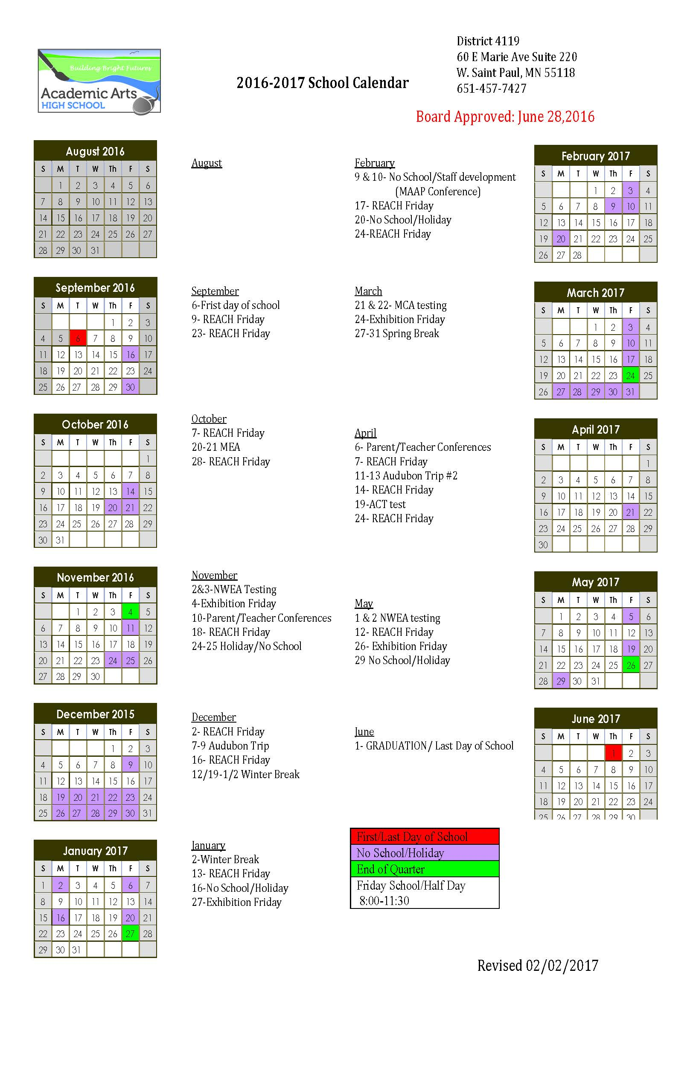

Innovative Practices & Implementation

Academic Arts High School is deeply invested in preparing students for life outside of High School. We utilize project-based learning to reach that goal because it reflects the way students will live their lives after graduation. Group work is highly emphasized and reflects the team-oriented environment of the workplace.
REACH Program: During this school year, Academic Arts HS implemented the REACH program, which originated at Hutchinson High School. The Mission of the REACH program is to “REACH out and serve all students who need support, by helping them attain their place in life through academic and interpersonal success.” The REACH program is designed to focus and address what is happening outside of school that affects students academically. The program gives the student a voice and place to belong in their school. It provides a venue to develop a social and emotional connection between students and advisors. It addresses students’ needs through sharing and goal setting to promote personal growth. REACH stands for Relationships Education Accountability Character & Hard Work.
Implementation of the REACH program is a team effort of investing in the students and in staff who are making valuable connections that result in student improvement.
On Monday, students gather in their REACH groups to debrief on their weekend; they talk about the good, the bad, and the ugly. On Tuesdays, students set or review their goals. Goals can be both long and short term, but each week they are reviewed for progress. Students develop a school, personal, and family goal. On Wednesday, groups complete a group activity which is designed to enhance team building. On Thursdays, students have individual check-ins with their advisor while the other students in their group use the extra time to complete homework.
Academic Arts High School incorporates themes of Environmental Education, Technological Literacy and Social-Emotional Wellness throughout all scholastic disciplines. We do this because we believe that, alongside academic success, these themes are the cornerstone of healthy and responsible individuals. We teach these things cohesively throughout each classroom. Students utilize multiple forms of technology, including 3D printers and scanners, coding, software programs and other tools to facilitate fluid technological literacy and adaptability.

Key successes from the past school year
During the 2016/17 school year, we adjusted the students schedule so that there are longer block periods each day and fewer subjects per day. The adjustment to the schedule allows students time to dig in and focus on the lecture and the coursework associated with the topic. Students receive the same amount of lesson time in each subject over the week but interact with fewer subjects per day. Students have reported that this system works better for them.
Technology Improvements:
- The addition of a wireless projector unit has enabled the math class to be interactive. Students are utilizing laptops and their cell phones as classroom learning tools and can share what they are working on via the wireless projector. This enables small group work, presentations of work and interactive examples when students have questions.
- A 3D scanner has been added to our 3D modeling and printing tools. The 3D printer allows students to scan an object, and use the 3D scan to reverse-engineer the object. Students can learn how it was made and why before making improvements on the model.
- We invested in a Flight Simulator software program called Kerbal Space. Students must build their spacecraft, then launch and navigate a space craft. The program is based on solid scientific grounds and provides students with an interactive science program.
A Strategic Planning Committee was developed during this school year. The committee is working on developing three and five-year plans for the school. They are identifying an ideal goal for the school which is in alignment with the Mission and Vision.
Student Ambassador Program: During the school year we received feedback from students that they wanted more leadership opportunities within our school. In response, the Advisors developed the Student Ambassador Program. Student Ambassadors will represent the school in the community, attend board meetings, lead school tours, work on grant applications applicable to student projects, plan school events, and develop fundraising strategies for the school. During the Spring of 2017 students applied for these positions for the next school year. Students were interviewed and selected based on their applications and interviews.
AAHS was able to purchase two new 10 passenger vans for this school year. These enable small group learning excursions and saves the school the cost of renting busses.
An update to the Family Leave Policy allows for all families with a natural born or adopted child to receive the same amount of leave regardless of gender.

Key challenges from past school year
While student attendance has increased again from previous years, it continues to be a challenge for our students to attend school regularly and on time. The implementation of the REACH program had positive results and will be continued as our attendance intervention strategy.
Planning for the transition to a Teacher Powered School model has been a positive challenge for our staff. As a result, team members have grown into leadership positions. Professional growth can be uncomfortable, but has shown to be a positive experience from what we have discovered through this process.

Academic Performance: Goals & Benchmarks

Progress on ACNW Contractual Academic Goals & WBWF Alignment

World’s Best Workforce (WBWF) Goal Areas:
- Ready for Kindergarten [R4K]: All students are ready for kindergarten.
  - Not Applicable, Academic Arts High School does not serve PreK or Kindergarten students.
- Reading Well by 3rd Grade [RG3]: All students in third grade achieve grade-level literacy.
  - Not Applicable, AAHS does not serve third-grade students.
- Achievement Gap Closure [AGC]: All racial and economic achievement gaps between students are closed.
  - 2014/15: Based on NWEA test scores, there is no fall-to-spring test data for students identified in racial or economic subgroups. We cannot, at this time, measure achievement gap closure based on this metric.
  - 2015/16: Differences in ethnic groups for Continuously Enrolled students minimal and not useful for determining progress towards closing the achievement gap.
  - 2016/17: Differences in ethnic groups for Continuously Enrolled students minimal and not useful for determining progress towards closing the achievement gap.
- Career and College Ready [CCR]: All students are career- and college-ready before graduating from high school. (AAHS Post-Secondary Readiness Measure 9.4: the aggregate percentage of students that complete their Life Plan project with a grade of C or better will be at least 75.0%.)
  - 2014/15: 80% of graduating seniors during the 2014/15 school year completed the Life Plan project and met AAHS criteria for career and college ready.
  - 2015/16: 26 college credits were collected by students in PSEO during this school year. 53% of graduating seniors during the 2015/16 school year completed the Life Plan project with a grade of C or better and meet AAHS criteria for career and college ready.
  - 2016/17: 78.26% of seniors who graduated during 2016/17 completed the Life Plan with a grade of C or better.
- Graduate from High School [GRAD]: All students graduate from high school.
  - 2014/15: 87% students enrolled on October 1 on-track for graduation, succeeded in graduating during the 2014/15 school year.
  - 2015/16: 71% of students enrolled on October 1 who were on-track for graduation, succeeded in graduating during the 2015/16 school year.
  - 2016-17: 64% of students enrolled on October 1 who were on-track for graduation succeeded in graduating during the 2016/17 school year. 22 Students graduated, eight planned to continue and pursue graduation for the next school year.
While the percentage of student graduates has decreased steadily over the last three years, the number of students enrolled who are on track for graduation in the fall has increased. We are graduating more students each year, but due to larger enrollment numbers the percentage has decreased. AAHS does not necessarily see this as a negative trend. AAHS counts all students, and graduates who are fifth, sixth, or seventh year seniors in the data reported here. This differs from the data which is currently reported on the MN Report Card, which only counts four-year graduates. This accounts for the discrepancy in the two data points.
Indicator 1: Mission-Related
Goal: Over the period of the contract, students at Academic Arts High School (AAHS) will
demonstrate stronger building blocks of healthy development.
Measure 1.1 – 5%: From FY16 to FY17, the aggregate percent decrease of the number of students who score in the challenged or vulnerable range on the Search Institute School Assets subscale from fall to spring of the same year will be at least 30.0%.
• Exceeds Standard: The aggregate percent decrease is at least 40.0%.
• Meets Standard: The aggregate percent decrease is at least 30.0%.
• Approaches Standard: The aggregate percent decrease is at least 20.0%.
• Does Not Meet Standard: The school did not meet the criteria for any of the ratings above.
Does Not Meet Standard. In FY17 AAHS tested students in the fall and spring. In the fall, 57% of students tested as Challenged or Vulnerable. In the Spring, the percentage decreased to 50%; a decrease of 16%.
Measure 1.2 – 5%: From 2015 to 2017, the aggregate percentage of continuing, non-graduating students who are enrolled in the spring, re-enroll in the subsequent academic year, and remain enrolled through at least October of that year will be at least 75.0%.
• Exceeds Standard: The aggregate percentage is at least 90.0%.
• Meets Standard: The aggregate percentage is at least 75.0%.
• Approaches Standard: The aggregate percentage is at least 65.0%.
• Does Not Meet Standard: The school did not meet the criteria for any of the ratings above.
2014/15: Does Not Meet Standard. Rollover enrollment from Spring 2014 to Fall 2015 was 43%.
2015/16: Does Not Meet Standard. Rollover enrollment from Spring 2015 to Fall 2016 was 51%.
2016/17: Approaches Standard. Rollover Enrollment from Spring 2016 to Fall 2017 was 62.59%
WBWF Goal Areas Addressed by this Goal: Career and College Ready
Key Measures & Results for this Goal: Provide an analysis of the school’s performance on this goal, addressing key measures.
Indicator 2: English Language Learners
Goal: The school does not have a contractual goal in this indicator area as it does not serve a significant population of English Learners.
Indicator 3: Reading Growth
Goal: Over the period of the contract, students at AAHS will demonstrate growth in reading as measured by nationally normed assessments.
Measure 3.1 [CCR] – 10%: From FY16 to FY18, the school will earn at least 70.0% of possible growth index points* on the NWEA MAP-Reading.
• Exceeds Standard: The school earns at least 90.0% of possible growth index points.
• Meets Standard: The school earns at least 70.0% of possible growth index points.
• Approaches Standard: The school earns at least 60.0% of possible growth index points.
• Does Not Meet Standard: The school did not meet the criteria for any of the ratings above.
Meets Standard: Academic Arts students earned 72% of possible credit index points on the Reading NWEA. Information on how credit index points were calculated can be found in Appendix 1.
Measure 3.2 [CCR] – 10%: From FY16 to FY18, the school will earn at least 70.0% of possible growth index points* on the NWEA MAP-Language Usage.
• Exceeds Standard: The school earns at least 90.0% of possible growth index points.
• Meets Standard: The school earns at least 70.0% of possible growth index points.
• Approaches Standard: The school earns at least 60.0% of possible growth index points.
• Does Not Meet Standard: The school did not meet the criteria for any of the ratings above.
WBWF Goal Areas Addressed by this Goal: Achievement Gap Reduction
Key Measures & Results for this Goal: Provide an analysis of the school’s performance on this goal, addressing key measures.
Meets Standard: Academic Arts students earned 73% of possible credit index points on the Language NWEA. Information on how credit index points were calculated can be found in Appendix 1.
Indicator 4: Math Growth
Goal: Over the period of the contract, students at AAHS will demonstrate growth in math as
measured by nationally normed assessments.
Measure 4.1 [CCR] – 10%: From FY16 to FY18, the school will earn at least 70.0% of possible growth index points* on the NWEA MAP-Math.
• Exceeds Standard: The school earns at least 90.0% of possible growth index points.
• Meets Standard: The school earns at least 70.0% of possible growth index points.
• Approaches Standard: The school earns at least 60.0% of possible growth index points.
• Does Not Meet Standard: The school did not meet the criteria for any of the ratings above.
Meets Standard: Academic Arts students earned 72% of possible Growth Index points on the NWEA MAP-Math.
WBWF Goal Areas Addressed by this Goal: Achievement Gap Reduction
Key Measures & Results for this Goal: Provide an analysis of the school’s performance on this goal, addressing key measures.
Indicator 5: Reading Proficiency
Goal: Over the period of the contract, students at AAHS will demonstrate proficiency in reading as measured by state accountability tests.
Measure 5.1 [CCR] – 5%: From FY15 to FY17, the school’s aggregate proficiency index score will be equal to or greater than that of the state for the same grades (grade 10), OR it will increase by at least 15.0 points from the baseline proficiency index score (baseline score – 50.0).
• Exceeds Standard: The school’s aggregate proficiency index score is at least 15.0 points above the state’s score, OR it is at least 20.0 points above the baseline score.
• Meets Standard: The school’s aggregate proficiency index score is equal to or greater than the state’s score, OR it is at least 10.0 points above the baseline score.
• Approaches Standard: The school’s aggregate proficiency index score is within 10.0 points of the state’s score, OR it is at least 5.0 points above the baseline score.
• Does Not Meet Standard: The school did not meet the criteria for any of the ratings above.
Does Not Meet Standard: During the spring of 2017, 47.1% of all students in 10th grade at Academic Arts High School tested proficient on the Reading MCA. This is an increase of 29.9% from 2015 and is only 13.1% behind the State average for ALL students.
WBWF Goal Areas Addressed by this Goal: Achievement Gap Reduction
Key Measures & Results for this Goal: Provide an analysis of the school’s performance on this goal, addressing key measures.
Indicator 6: Math Proficiency
Goal: Over the period of the contract, students at AAHS will demonstrate proficiency in math as measured by state accountability tests.
Measure 6.1 [CCR] – 5%: From FY15 to FY17, the school’s aggregate proficiency index score will be equal to or greater than that of the state for the same grades (grade 11), OR it will increase by at least 15.0 points from the baseline proficiency index score (baseline score – 4.4).
• Exceeds Standard: The school’s aggregate proficiency index score is at least 15.0 points above the state’s score, OR it is at least 30.0 points above the baseline score.
• Meets Standard: The school’s aggregate proficiency index score is equal to or greater than the state’s score OR it is at least 15.0 points above the baseline score.
• Approaches Standard: The school’s aggregate proficiency index score is within 10.0 points of the state’s score, OR it is at least 10.0 points above the baseline score.
• Does Not Meet Standard: The school did not meet the criteria for any of the ratings above.
Does Not Meet Standard: During the spring of 2017, 4% of students in 11th grade at Academic Arts High School tested proficient on the Mathematics MCA. This is a decrease of 2.3% from the previous school year.
WBWF Goal Areas Addressed by this Goal: Achievement Gap Reduction
Key Measures & Results for this Goal: Provide an analysis of the school’s performance on this goal, addressing key measures.
Indicator 7: Science Proficiency
Goal: Over the period of the contract, students at AAHS will demonstrate proficiency in science as measured by state accountability tests.
Measure 7.1 [CCR] – 5%: From FY15 to FY17, the school’s aggregate proficiency index score will be equal to or greater than that of the state for the same grades (High School), OR it will increase by at least 15.0 points from the baseline proficiency index score (baseline score – 18.8).
• Exceeds Standard: The school’s aggregate proficiency index score is at least 15.0 points above the state’s score, OR it is at least 30.0 points above the baseline score.
• Meets Standard: The school’s aggregate proficiency index score is equal to or greater than the state’s score, OR it is at least 15.0 points above the baseline score.
• Approaches Standard: The school’s aggregate proficiency index score is within 10.0 points of the state’s score, OR it is at least 10.0 points above the baseline score.
• Does Not Meet Standard: The school did not meet the criteria for any of the ratings above.
Does Not Meet Standard. During the spring of 2017, students enrolled in a Science class at Academic Arts High School tested as 35.7% proficient on the Science MCA. This is a 13% increase from the previous school year and 20.6% behind the State average.
WBWF Goal Areas Addressed by this Goal: Achievement Gap Reduction
Key Measures & Results for this Goal: Provide an analysis of the school’s performance on this goal, addressing key measures.
Indicator 8: Proficiency in Other Curricular Areas
Goal: The school does not have a contractual goal in this optional indicator area.
Indicator 9: Post-Secondary Readiness
Goal: Goal: Over the period of the contract, students at AAHS will demonstrate readiness for post secondary success.
Measure 9.1 [CCR] –6%: From FY16 to FY17, the aggregate percentage of graduating students who earn a score of college ready or needing no more than one semester of remediation on the Accuplacer-Reading will be at least 70.0%.
• Exceeds Standard: The aggregate percentage is at least 80.0%.
• Meets Standard: The aggregate percentage is at least 70.0%.
• Approaches Standard: The aggregate percentage is at least 60.0%.
• Does Not Meet Standard: The school did not meet the criteria for any of the ratings above.
Accuplacer did not share student test scores with our school this year; we are unable to report on this measure.
Measure 9.2 [CCR] – 6%: From FY16 to FY17, the aggregate percentage of graduating students who earn a score of college ready or needing no more than one semester of remediation on the Accuplacer-Math will be at least 70.0%.
• Exceeds Standard: The aggregate percentage is at least 80.0%.
• Meets Standard: The aggregate percentage is at least 70.0%.
• Approaches Standard: The aggregate percentage is at least 60.0%.
• Does Not Meet Standard: The school did not meet the criteria for any of the ratings above.
Accuplacer did not share student test scores with our school this year; we are unable to report on this measure.
Measure 9.3 [CCR] – 6%: From FY16 to FY17, the aggregate percentage of graduating students who earn a score of college ready or needing no more than one semester of remediation on the Accuplacer-Writing will be at least 70.0%.
• Exceeds Standard: The aggregate percentage is at least 80.0%.
• Meets Standard: The aggregate percentage is at least 70.0%.
• Approaches Standard: The aggregate percentage is at least 60.0%.
• Does Not Meet Standard: The school did not meet the criteria for any of the ratings above.
Accuplacer did not share student test scores with our school this year; we are unable to report on this measure.
Measure 9.4 [CCR] – 6%: From FY16 to FY17, the aggregate percentage of students that complete their Life Plan project with a grade of C or better will be at least 75.0%.
• Exceeds Standard: The school earns at least 80.0%.
• Meets Standard: The school earns at least 70.0%.
• Approaches Standard: The school earns at least 60.0%.
• Does Not Meet Standard: The school did not meet the criteria for any of the ratings above.
2016/17: Meets Standard. Of students who were on track to graduate on October 1, 78.26% earned a grade of C or better on their Life Plan project. Some of these students had completed the Life Plan project in previous years as they took more than four years to graduate.
Measure 9.5 [CCR] – 8%: From FY16 to FY18, the school will earn at least 75.0% of possible credit index points.*
• Exceeds Standard: The school earns at least 90.0% of possible credit index points.
• Meets Standard: The school earns at least 75.0% of possible credit index points.
• Approaches Standard: The school earns at least 60.0% of possible credit index points.
• Does Not Meet Standard: The school did not meet the criteria for any of the ratings above.
2016/17: Approaches standard. Based on NWEA Credit Index points, the school earned 72% of available points across all subjects.
Measure 9.6 [GRAD] – 6%: From FY16 to FY17, the aggregate percentage of students that graduate on or before their identified Graduation Year will be at least 70.0%.
• Exceeds Standard: The aggregate percentage is at least 80.0%.
• Meets Standard: The aggregate percentage is at least 70.0%.
• Approaches Standard: The aggregate percentage is at least 60.0%.
• Does Not Meet Standard: The school did not meet the criteria for any of the ratings above.
Approaches Standard. 64% of students enrolled on October 1 who were on-track for graduation succeeded in graduating during the 2016/17 school year. Twenty-two students graduated; eight planned to continue and pursue graduation for the next school year.
WBWF Goal Areas Addressed by this Goal: Career and College Ready
Key Measures & Results for this Goal: Provide an analysis of the school’s performance on this goal, addressing key measures.
Indicator 10: Federal and State Accountability
Goal: The school does not have a contractual goal in this indicator area. ACNW will evaluate the school’s performance in this area based on results from the Multiple Measurement System.
Indicator 11: Attendance
Goal: Goal: Over the period of the contract, students at AAHS will attend the school at high rates.
Measure 11.1 – 7%: From FY15 to FY17, the average of the school’s annual attendance rates will be at least 85.0%.
• Exceeds Standard: The average of the school’s annual attendance rates is at least 92.0%.
• Meets Standard: The average of the school’s annual attendance rates is at least 85.0%.
• Approaches Standard: The average of the school’s annual attendance rates is at least 80.0%.
• Does Not Meet Standard: The school did not meet the criteria for any of the ratings above.
Approaches Standard. The school’s overall attendance rate was 81.58%
WBWF Goal Areas Addressed by this Goal: Graduation Rates
Key Measures & Results for this Goal: Provide an analysis of the school’s performance on this goal, addressing key measures.
Additional Academic Data
Consider the goal information already provided. In this section, include additional data (narratives and/or tables/charts/graphs) that would be helpful to tell your school’s story to the public.

Educational Effectiveness: Assessment & Evaluation
Annually our Leadership Team meets to review student achievement data from the school year, completes a retrospective analysis of the school year from our perspective as school teachers and administrative leadership, and then we make determinations of what changes will be made to the educational program. The leadership team of Academic Arts looks at student information by classroom, subject area, demographic information, credits earned, and progress towards graduation. With a small school size, we know each student’s situation in life and are able to monitor their progress individually and as a demographic group.
Our process for reviewing and evaluating the strengths and weaknesses of our curriculum was done through:
  - Weekly curriculum meetings (PLCs)
  - Project-tuning sessions
  - MCA, NWEA, and other data such as grade fluctuations amongst subjects, quarters, and teachers.
  - We hold a staff development meeting at the end of each year to discuss struggles and possible improvements for the coming school year.
This year, our strategies for improving instruction were to implement unit themes amongst all core classes, co-teaching for several classes, a set block schedule (1st week: experiences related to curriculum/theme; 2nd week: direct instruction; 3rd/4th week: project work). We used REACH (advisory time) to focus on struggles students had in/out of school to improve attention during class hours.
We have weekly curriculum meetings (Content/PLCs). Each week all general education teachers, as well as two special education teachers, meet to discuss academic goals, curriculum, teaching struggles, etc. We adjust curriculum and teaching strategies after each meeting. We also meet for "project tuning" sessions in which we pitch new unit ideas and get them finely tuned by other teachers.
AAHS operates around strong Advisory Groups, where a teacher works closely with their student group to advise and guide their educational progress. For each student, the advisor monitors the student’s attendance, project completion, and credits earned. Graduation plans are developed between the student, and the advisor and the advisor monitors progress quarterly and yearly.
Our teaching and leadership staff are evaluated by utilizing a teacher evaluation progress, consider parent feedback and feedback and evaluations from the Authorizer and MN Department of Education. The school has also, in the past, contracted with outside agencies for a school evaluation.
Teacher evaluations are done yearly, and our process is modeled after the MN Department of Education’s model for teacher evaluations. Our evaluation has multiple points of contact and is careful to track progress on student learning goals. The curriculum is reviewed and adjusted yearly based on prior year feedback from teachers and parents. As a project-based school, we have ample flexibility in our curriculum. The school director is evaluated yearly by the school board, in accordance with best practices.
The Instructional Lead does quarterly evaluations on each general education teacher; we work on specific goals in instruction, classroom management, professionalism, and overall performance. We also do two peer evaluations throughout the school year in which every teacher takes a day to observe lessons in other classrooms. This year, we did full-staff peer evaluations to include performance school-wide and in various categories not directly about instruction.

Student & Parent Satisfaction
For the second year in a row, Academic Arts High School administered the Search Institute’s Survey for all students. The Search Institute’s “Developmental Assets Framework” is a “research-based approach to understanding the strengths and supports that young people need in their lives to prepare for a positive, productive future. Extensive research has shown that having these assets in their lives helps young people make positive life choices, affecting their growth as they move through childhood and adolescence into adulthood. The higher levels of assets young people experience across their lives, the more likely they are to do better in school; Be prepared for post-high school education and careers; contribute more to their communities and society, and; Avoid high-risk behaviors, such as violence, substance abuse, and sexual activity.”
The Search Institute survey was administered twice within the school year, once in September of 2016 and again in May of 2017. The purpose of administering it twice was to analyze students’ improvement over the course of the school year. Overall, the survey results show improvement from fall to spring. In the fall, students reported 32.8 total assets; in the spring they reported 35.1 total assets.
Students at Academic Arts showed improvement in all of the 8 categories of assets except for Support and Constructive Use of Time. These two areas showed small decreases, where the areas of improvement all increased by more than one point.
The Composite Scores show a decrease in the number of students in the “Challenged” and “Vulnerable categories and a large increase for those in the “Adequate” category.
AAHS used this data into plan improvements for the 2017/18 school year. The school will be continuing the REACH program for the entirety of the school year and increasing programing around developing healthy practices for overall physical and mental health.

Environmental Education

The mission of Academic Arts High School’s authorizer, the Audubon Center of the North Woods, is to instill a connection and commitment to the environment in people of all communities through experiential learning. ACNW defines environmental education as the implementation of values and strategies that foster learning and create environmentally literate citizens who engage in creating healthy outcomes for individuals, communities, and the Earth. The overarching goal of environmental education is an environmentally literate citizenry. The test of environmental literacy is the capacity of an individual to work individually and collectively toward sustaining a healthy natural environment. This requires sufficient awareness, knowledge, skills, and attitudes to create a healthy planet where all people live in balance with the Earth.
Our approach to environmental education is simple: Get our students outside so as to foster awareness, knowledge, skills, attitudes, and participation that instill a connection and commitment to the environment. We have an urban population of students. Many do not have access to natural areas. We want our students to get out of their comfort zone, challenge them mentally and physically, and see their world differently. We also want to foster environmental stewardship and apply the LNT principles that we have been learning in classes and as a part of our school culture. Furthermore, we’ve adopted cross curricular themes in that focus on environmental issues including “food and energy” and “social/environmental justice.”

Governance & Management
Includes Annual Board Training & Administrator Professional Development Report(s)
BOARD OF DIRECTORS
Member Name | Board Position | Affiliation | Date Elected | Date Seated | Term End Date | Phone Number | Email Address
Amy Charpentier | Chair | Parent | 02/16/2016 | 02/16/2016 | 11/18/2017 | 651-457-7427 | amycharpentier50@yahoo.com
Courtney Finn | Member | Community Member | 01/19/2016 | 01/19/2016 | 01/19/2019 | 651-457-7427 | courtneyfinn81@gmail.com
Josh MacLachlan | Member | Teacher | 01/19/2016 | 01/19/2016 | 01/19/2019 | 651-457-7427 | josh.maclachlan@academicarts.org
Linnea Morgen | Secretary | Teacher | 01/19/2016 | 01/19/2016 | 01/16/2019 | 651-457-7427 | linnea.morgen@academicarts.org
Andrew Ng | Member | Teacher | 11/18/2014 | 11/18/2014 | 11/18/2017 | 651-457-7427 | andrew.ng@academicarts.org
Dean Walczak | Financial Manager | Community Member | NA | NA | NA | 651-457-7427 | NA
Krissy Wright | Ex-Officio | Director | NA | NA | NA | 507-351-0422 | krissy.wright@academicarts.org
Rita Hussman | Member | Community Member | 10/18/16 | 11/15/16 | 11/18/17
Bill Zimniewicz | Chair | Community Member | 11/18/2014 | 11/18/2014 | 10/18/16 | 651-457-7427 | bill@jenningsclc.org

Academic Arts High School has a good relationship with its board of directors. A board meeting takes place once a month at the school, and at that meeting, a non-board member representative from the school serves as an ex-officio member for that meeting to report to the board on events, academics, and other happenings. Three teachers are current board members, and they can work with the board as representatives of the school as well as work with the school as representatives of the board in the interest of pursuing the school's mission and vision.

Board Training and Development
Board Training for the FY16 school year was completed by Designs for Learning and addressed the three requirements of Governance, Personnel, and School Finance. Board Training for all board members was completed on December 10, 2016.

Annual Training – FY17
Board Member Name | Date of Training | Training Title or Topic | Presenter or Trainer
Amy Charpentier | 12/10/2016 | Governance, Personnel, & School Finance | Designs for Learning
Courtney Finn | 12/10/2016 | Governance, Personnel, & School Finance | Designs for Learning
Josh MacLachlan | 12/10/2016 | Governance, Personnel, & School Finance | Designs for Learning
Linnea Morgen | 12/10/2016 | Governance, Personnel, & School Finance | Designs for Learning
Andrew Ng | 12/10/2016 | Governance, Personnel, & School Finance | Designs for Learning
Dean Walczak | 12/10/2016 | Governance, Personnel, & School Finance | Designs for Learning
Krissy Wright | 12/10/2016 | Governance, Personnel, & School Finance | Designs for Learning

MANAGEMENT
Academic Arts High School contracts with the following organizations:
- Contracts with Tammy Pulver for Special Education Services
- Contracts with Designs for Learning for Program Support Services
- Contracts with Done Right Foods for Food Service
- Contracts with Dean Walzack of DW Financial Management LLC for School Business Services
One key change in school management for the 2017/18 school year is that our School Director, Krissy Wright, will be leaving her post as director. Instead of filling this position Academic Arts High School will be implementing a Teacher Powered School Model. This is discussed more thoroughly in future plans.

LIST OF ADMINISTRATORS/QUALIFICATIONS
- Shoua Yang: Administrative Manager & MARSS Coordinator
- Lauryn Davin, Administrative Assistant, and Nutritional Program Coordinator
- Monica Darrico, Receptionist
- Krissy Wright, Director
- Kelley Thompson, Instructional Lead

PROFESSIONAL DEVELOPMENT PLAN FOR Krissy Wright, Director
PROFESSIONAL DEVELOPMENT PLAN FOR Krissy Wright, Director
Activities Completed/Progress/Results for 2016-17:
(i.e., implementation of the professional development plan)
● Worked with a small caseload of students receiving special education services. Case manager for students receiving homebound services.
● Joined the Minnesota Association of Charter Schools board. Met with legislators with students and individually.
● Maintained steady enrollment at or near capacity. Employed the wait list a couple times.
● Helped implement a completely distributive and flat leadership model. The school will function as a teacher-powered school without a director beginning the 2017-18 school year.
● Two new parent members on the school board who are heading parent engagement efforts.
Professional Development Goals/Areas of Focus for 2017-18:
Krissy will not be returning for the 2017-18 school year. This was planned and the school will continue as a teacher-powered school without a director.
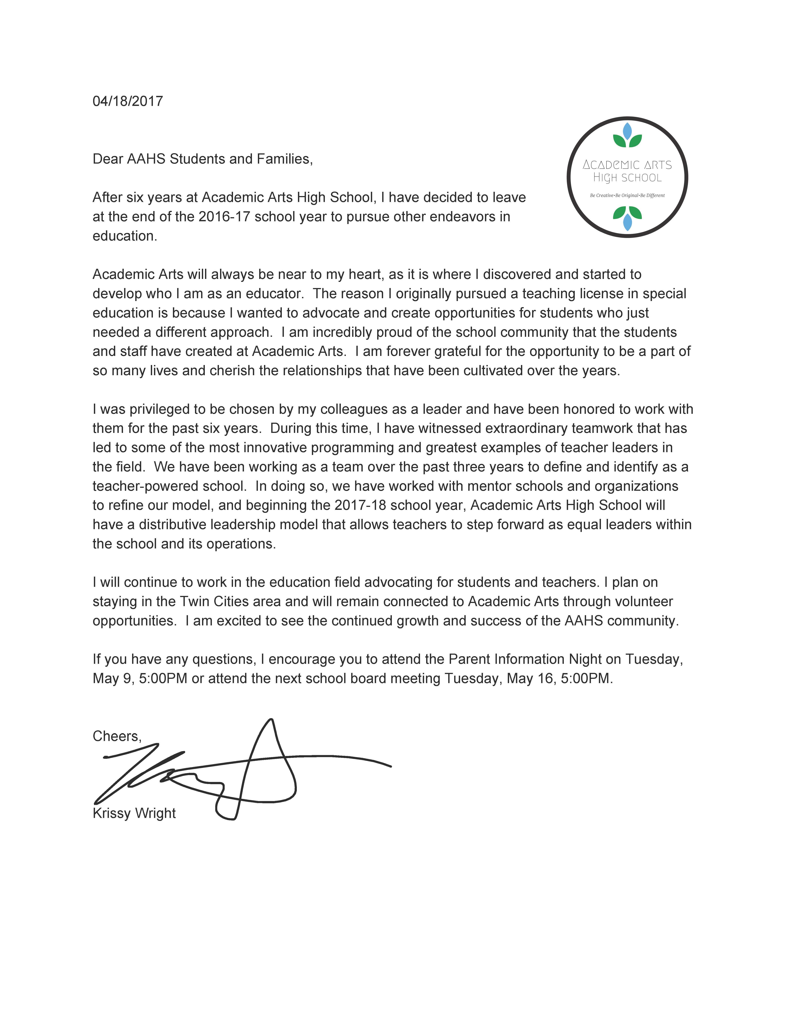

Staffing
Staffing at Academic Arts is one of our greatest strengths. Teachers and school staff are committed to the Mission and Vision of the school and return from year to year consistently. This year we have a notable staff change in that our director is leaving the school and that position will not be filled. We also had a small turnover in our school support positions.
2016-17 Staffing

2016-2017 Licensed Teaching Staff
Name | File # | License and Assignment | 2017/18 Status*
Bade, Stephanie | 996502 | Special Education | Returning
Fjelstad, Heather | 476801 | Special Education Coordinator | Returning
MacLachlan, James | 443250 | Science Teacher | Returning
Massey, David | 460536 | Science Teacher | Returning
Morgen, Linnea | 482162 | Social Studies | Returning
Ng, Andrew | 449484 | Mathematics | Returning
Peterson, Julie | 997261 | Special Education | Returning
Thompson, Kelly | 460463 | Instructional Lead, Title I Reading | Returning
Wright, Krissy | 463254 | Director, Special Education | Not Returning
Cody, Ty | 474875 | School Psychologist & Homeless Liaison | Returning
* R = Returning, NR = Not Returning
Percentage of Licensed Teachers from 2016-17 not returning in 2017-18 (non-returning teachers/total teachers from 2016-17 x 100) | 10%

2016-2017 Non-Licensed Staff
Name | Assignment | 2017/18 Status* | Comments
Brose, Joshua | Paraprofessional | R
Cady, Altomari | Paraprofessional | R
Cody, Ty | School Psychologist | R
Garrido, Monica | Administrative Assistant | R | Spanish Speaking
Kah, Dua | Paraprofessional | R
Lavarato, Elaina | Paraprofessional | R
Parilla, Mari | Paraprofessional | R | Spanish Speaking
Reed, Michael | Paraprofessional | R
Yang, Shoua | Administrative Manager | R
* R = Returning, NR = Not Returning

CURRENT YEAR - 2017-18 Staffing

2017-18 NEW Licensed Teaching Staff
Name | File # | License and Assignment (subject/grades) | Comments
David Massey | 460563 | Science Instructor | Upcycling Advisor

2017-18 NEW Non-Licensed Staff
Name | Assignment | Comments
Sam Kvilhaug | Behavior Lead
Sammarie Smith | Paraprofessional

Staff Development Table
Below is our staff professional development matrix. It details all of the Professional Development activities for the FY17 school year, and which teaching staff attended them.
 | ACNW EE  Workshop: 8/1/16- 8/2/16 | Teacher-Powered Schools Governance: 8/16/16 | REACH  Workshop: 8/29/16 | ACNW Leader's Retreat: 11/11/16- 11/12/16 | Education Evolving (TPS): 12/2/16 | National Teacher- Powered Schools Conference: 1/28/17-1/29/17 | MAAP  Conference: 2/8/17-2/10/17 | Edvisions Spring Conference: 3/10/17 | Institute for Non-Formal Climate Change Education at ACNW: 3/13/17-3/15/17 | At-Risk for High School Educators - Kognito training for mental health referrals 2/1/17
Stephanie Bade |  |  |  |  |  |  | X
Ty Cody |  |  | X |  | X |  | X | X |  | X
Heather Fjelstad |  |  |  |  |  |  | X
Sam Kvilhaug |  |  |  |  |  |  | X
Josh MacLachlan | X |  | X | X | X | X | X | X | X
David Massey |  |  |  |  |  |  | X
Linnea Morgen |  | X |  |  | X | X | X | X
Andrew Ng | X |  |  | X | X | X | X | X |  | X
Julie Peterson |  |  |  |  |  |  | X
Kelley Thompson |  | X |  |  | X |  | X | X
Krissy Wright |  |  |  |  |  | X | X

Operational Performance
Academic Arts High School materially complies with applicable laws, rules, regulations, and provisions of the charter contract relating to:
- Academic Arts High school completes relevant compliance and reporting requirements for the authorizer, state education agency, and/or federal authorities, including but not limited to:
  - State reporting and applications, including but not limited to MARSS, STARS, UFARS, EDRS, Q Comp, DIRS, lease aid;
  - TRA/PERA;
  - School website is compliant with statutory and authorizer expectations;
  - Insurance coverage;
- the school facilities, grounds and transportation, including but not limited to:
  - Fire inspections and related records;
  - Viable certificate of occupancy or other required building use authorization;
  - Physical space provides a safe, positive learning environment for students;
  - Appropriate and safe student transportation practices;
- health and safety, including but not limited to:
  - Nursing services and dispensing of pharmaceuticals;
  - Food service;
  - Emergency management plan;
- admission and enrollment rights of students, including but not limited to policies and practices related to admissions, lottery, waiting lists, fair and open recruitment;
- due process and privacy rights of students, including but not limited to:
  - Due process protections, privacy, civil rights and students liberties requirements, including First Amendment protections and the Establishment Clause restrictions prohibiting public schools from engaging in religious instruction;
  - Conduct of discipline pursuant to the Pupil Fair Dismissal Act;
  - Maintain the security of and provide access to students records under the Family Educational Rights and Privacy Act and other applicable authorities;
  - Transfer of student records;
- employment including transparent hiring, evaluation and dismissal policies and practices;
Background checks for all school employees are required

Finances

For questions regarding school finances and for complete financials for 2016-17 and/or an organizational budget for 2017-18, contact:
Name: Dean Walczak
Position: Finance Manager
Contact info:
Phone: 612-396-3694
Email: dean.walczak@dwfinman.com
Information presented below is derived from preliminary audit figures. The full financial audit will be completed and presented to the Minnesota Department of Education and Audubon Center of the North Woods no later than December 31, 2017.
FY17 Finances | Fund 1 | Fund 2 | Fund 4
Total Revenues | 1,482,454 | 3,073 | n/a
Total Expenditures | 1,470,110 | 27,394 | n/a
Net Income | 12,344 | -24321 | n/a
Total Fund Balance | 271,817 | -24321 | n/a

Overview
Overall the financial picture was healthy in the general fund as revenues exceeded expenses. Student ADM was close to predicted budgeted amounts. The Food Service fund remains a challenge and the school is adopting changes to reduce the overall Food Service fund deficit.
Revenues
The school’s revenue met budget projections as the primary source of funding is derived through the state based on student enrollment. Almost all revenue is derived from state sources through general education, special education and lease aid funding. Some revenue is received through Federal sources including Title 1 funds, Title 2 funds and Federal special education funds.
Expenses
The school’s expenses were lower than projected revenues. The largest portion of expense is toward salaried staff to meet the educational needs of the students served.
Net Surplus or Deficit and Fund Balance
The school’s general fund maintained a surplus yet the deficit in the schools food service fund means that the overall fund balance will decrease as the general funds surplus will be used to shore up the Food Service balance. The overall fund balance has decreased from the prior year.
World’s Best Workforce Annual Budget
All budget line items relate to the overall school goals in the World’s Best Workforce Plan.

Future Plans
Our school director, Krissy Wright, is leaving Academic Arts at the end of the 2016-2017 school year. During the current school year, we have been planning our movement to a Teacher Powered School model. At a teacher powered school all teachers will have the collective autonomy to make decisions influencing the success of the school. Roles and responsibilities of the school director have been allocated to teachers. Our Teachers will collectively make school decisions and run the school.
Below is the leadership map which documents the dissolution of the director position and the network of teachers that will fill those leadership obligations.
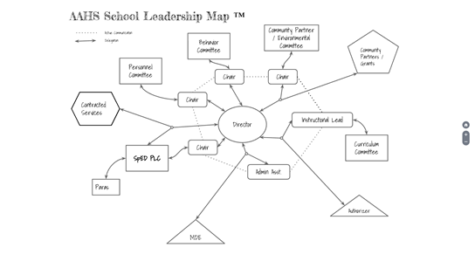

Appendix 1: NWEA Growth Index Points Calculations
2016-17 Math
Fall NWEA grade level equivalent | Below 60% of target x0 | 60-79% of target x 0.25 | 80-99% of target x 0.5 | 100-120% of target x 1 | Over 120% of target x 1.25 | Total student count
Students 2+ years behind grade level (at least 1.5 years of growth needed | 0 | 0 | 1 | 2 | 0 | 2.5
Students 1-2 years behind grade level (at least 1.5 years of growth needed | 0 | 1 | 3 | 6 | 0 | 7.5
Students at grade level (at least 1 year of growth needed) | 0 | 0 | 21 | 12 | 0 | 22.5
Students 1 or more years above grade level (maintain grade level or above) | 0 | 0 | 1 | 0 | 0 | 0.5
students 1 or more years behind grade level | 0 | 0 | 4 | 8 | 0 | 12
Students on grade level or less than 1 year behind (at least 1 Year of growth needed) | 0 | 0 | 22 | 12 | 0 | 34
Total Points Achieved | 0 | 0.25 | 13 | 20 | 0 | 33
Total Points Possible |  |  |  |  |  | 46
Percent of Points Achieved |  |  |  |  |  | 72%

2016-17 Reading
Fall NWEA grade level equivalent | Below 60% of target x0 | 60-79% of target x 0.25 | 80-99% of target x 0.5 | 100-120% of target x 1 | Over 120% of target x 1.25 | Total student count
Students 2+ years behind grade level (at least 1.5 years of growth needed | 0 | 0 | 1 | 2 | 0 | 2.5
Students 1-2 years behind grade level (at least 1.5 years of growth needed | 0 | 0 | 2 | 1 | 0 | 2
Students at grade level (at least 1 year of growth needed) | 0 | 1 | 14 | 14 | 0 | 21.25
Students 1 or more years above grade level (maintain grade level or above) | 0 | 0 | 5 | 2 | 0 | 4.5
students 1 or more years behind grade level | 0 | 0 | 3 | 3 | 0 | 6
Students on grade level or less than 1 year behind (at least 1 Year of growth needed) | 0 | 0 | 19 | 16 | 0 | 36
Total Points Achieved | 0 | 0.25 | 11 | 19 | 0 | 30.25
Total Points Possible | 0 | 1.25 | 27.5 | 23.75 | 0 | 42
Percent of Points Achieved |  |  |  |  |  | 72%

2016-2017 Language
Fall NWEA grade level equivalent | Below 60% of target x0 | 60-79% of target x 0.25 | 80-99% of target x 0.5 | 100-120% of target x 1 | Over 120% of target x 1.25 | Total student count
Students 2+ years behind grade level (at least 1.5 years of growth needed | 0 | 0 | 1 | 2 | 0 | 3
Students 1-2 years behind grade level (at least 1.5 years of growth needed | 0 | 0 | 1 | 3 | 0 | 4
Students at grade level (at least 1 year of growth needed) | 0 | 1 | 18 | 16 | 0 | 35
Students 1 or more years above grade level (maintain grade level or above) | 0 | 0 | 1 | 0 | 0 | 1
students 1 or more years behind grade level | 0 | 0 | 2 | 5 | 0 | 7
Students on grade level or less than 1 year behind (at least 1 Year of growth needed) | 0 | 0 | 19 | 16 | 0 | 36
Total Points Achieved | 0 | 0.25 | 10.5 | 21 | 0 | 31.5
Total Points Possible |  |  |  |  |  | 43
Percent of Points Achieved |  |  |  |  |  | 73%

The Norms used to determine if students fell one, two, or more than two years behind grade level follow next. The NWEA is not a test meant to measure grade level targets. This is not the most reliable measure of where a student falls on grade level proficiency. This data is meant to inform the growth of students in one school year.
Math NORMS |  |  | 1 yr behind |  | 2 yrs behind
7 | 206 | 238 | 190 | 206 | 174 | 190
8 | 209 | 243 | 192 | 209 | 175 | 192
9 | 212 | 248 | 194 | 212 | 176 | 194
10 | 211 | 249 | 192 | 211 | 173 | 192
11 | 214 | 242 | 195 | 214 | 176 | 195
12
Language NORMS |  |  | 1 yr behind |  | 2 yrs behind
7 | 201 | 227 | 188 | 201 | 175 | 188
8 | 202 | 230 | 188 | 202 | 174 | 188
9 | 204 | 232 | 190 | 204 | 176 | 190
10 | 203 | 233 | 188 | 203 | 173 | 188
11 | 207 | 235 | 193 | 207 | 179 | 193
Reading NORMS |  |  | 1 yr behind |  | 2 yrs behind
7 | 199 | 229 | 199 | 184 | 184 | 169
8 | 202 | 232 | 202 | 187 | 187 | 172
9 | 205 | 235 | 205 | 190 | 190 | 175
10 | 204 | 236 | 204 | 188 | 188 | 172
11 | 206 | 238 | 206 | 190 | 174 | 188

Kolb, David A, et al. Experiential Learning Theory: Previous Research and New Directions. Weatherhead School of Management, 1999.
Strengths and Supports in the Lives of Academic Arts High School Youth, Search Institute, August 2017, pp. 13-14.

